Task 21

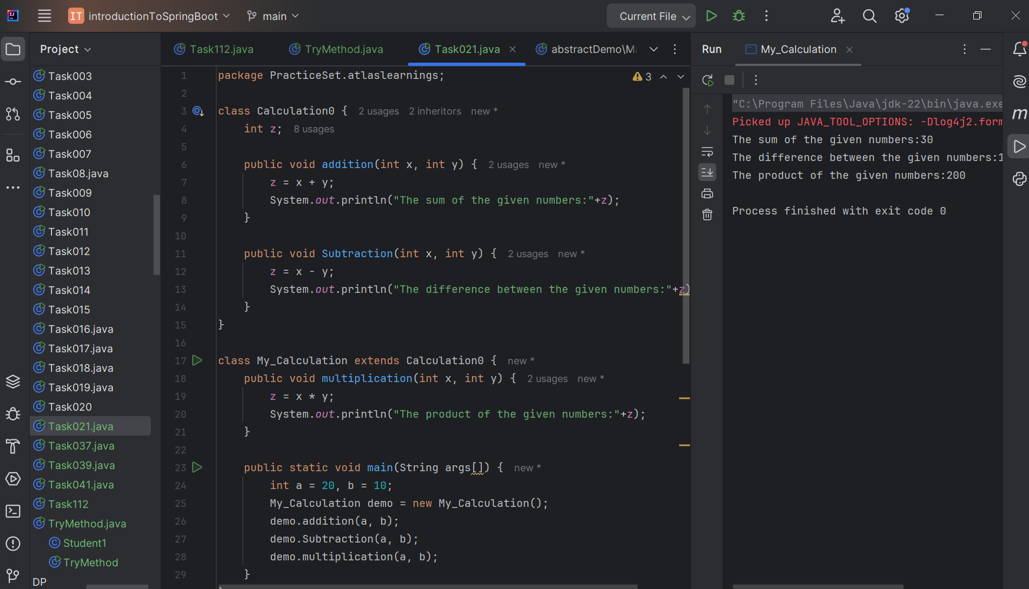

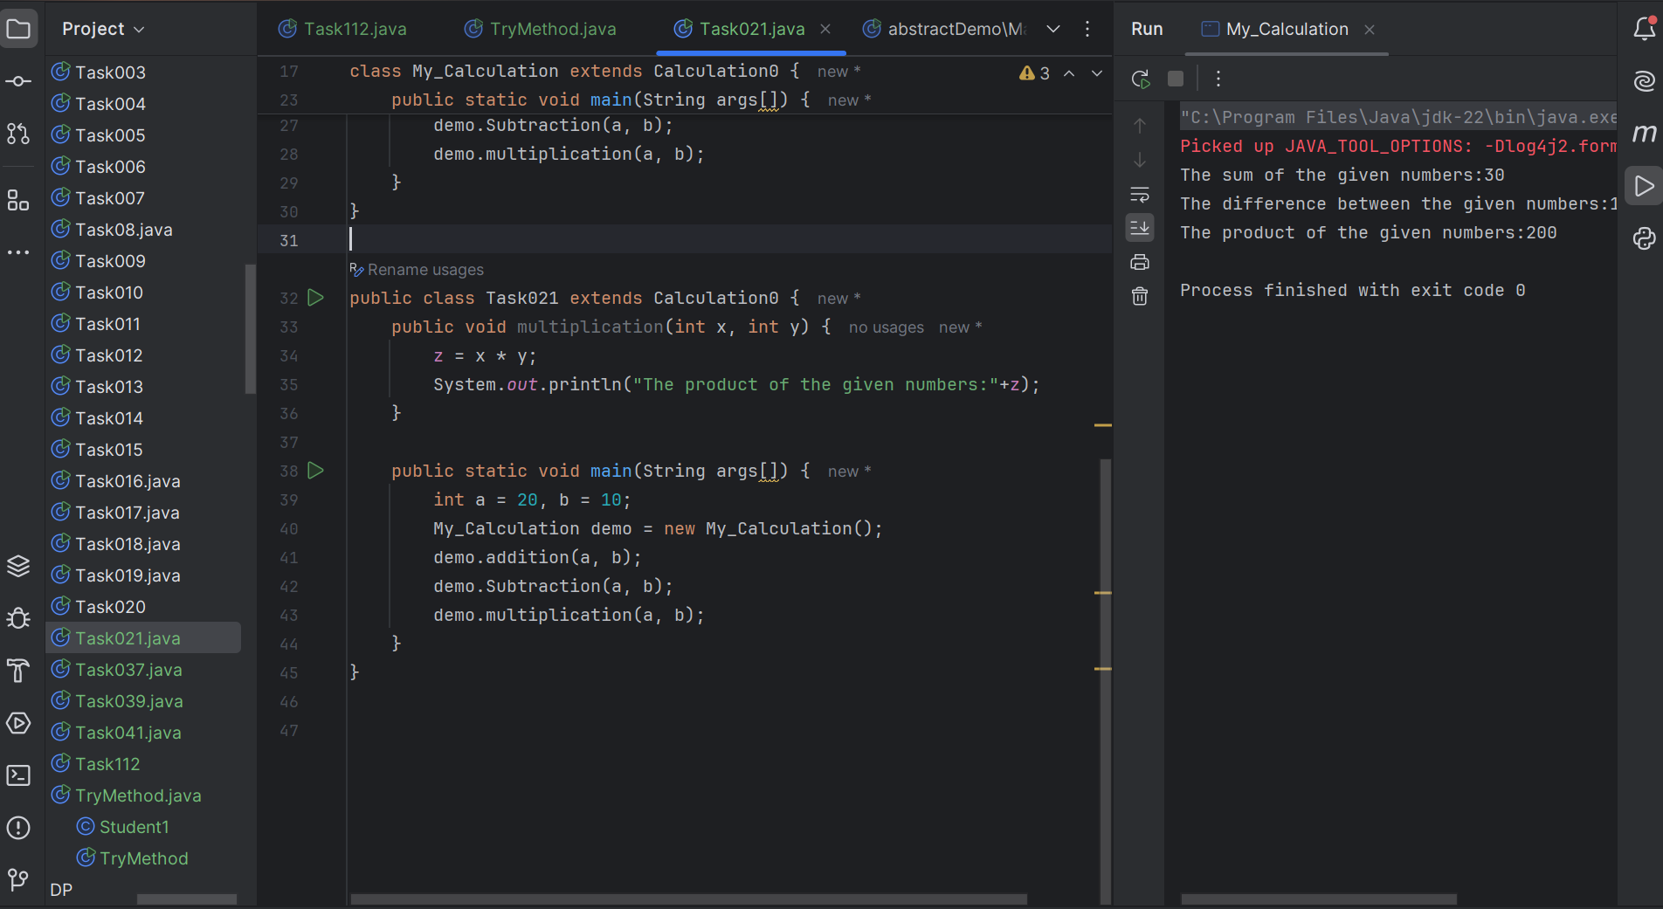

Task 22

Multiple inheritance is not allowed with classes in Java to avoid ambiguity and complexity

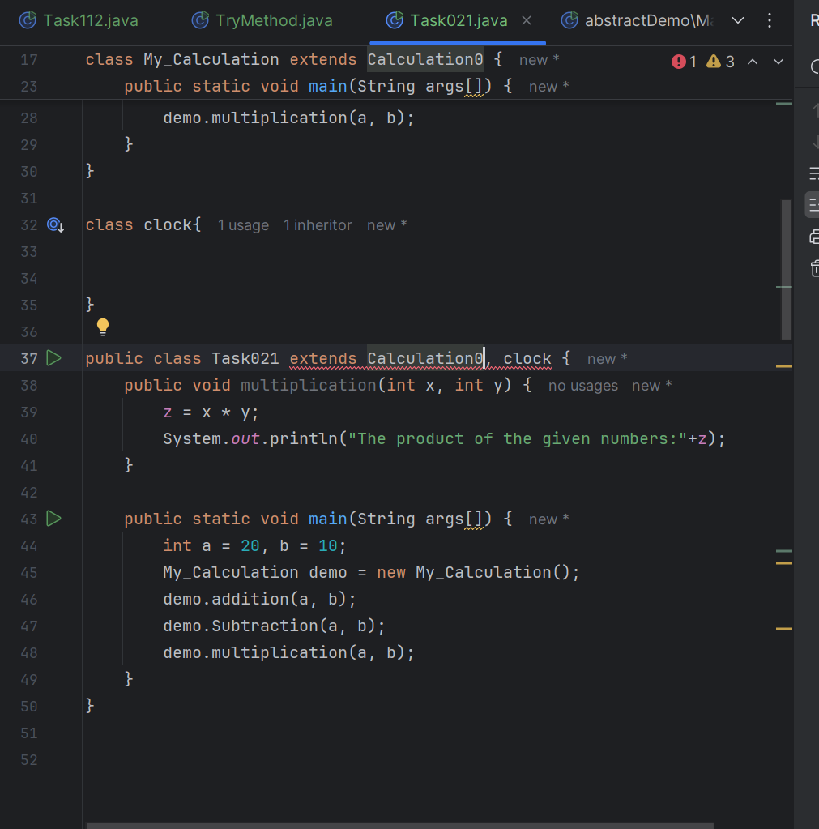

Task 23

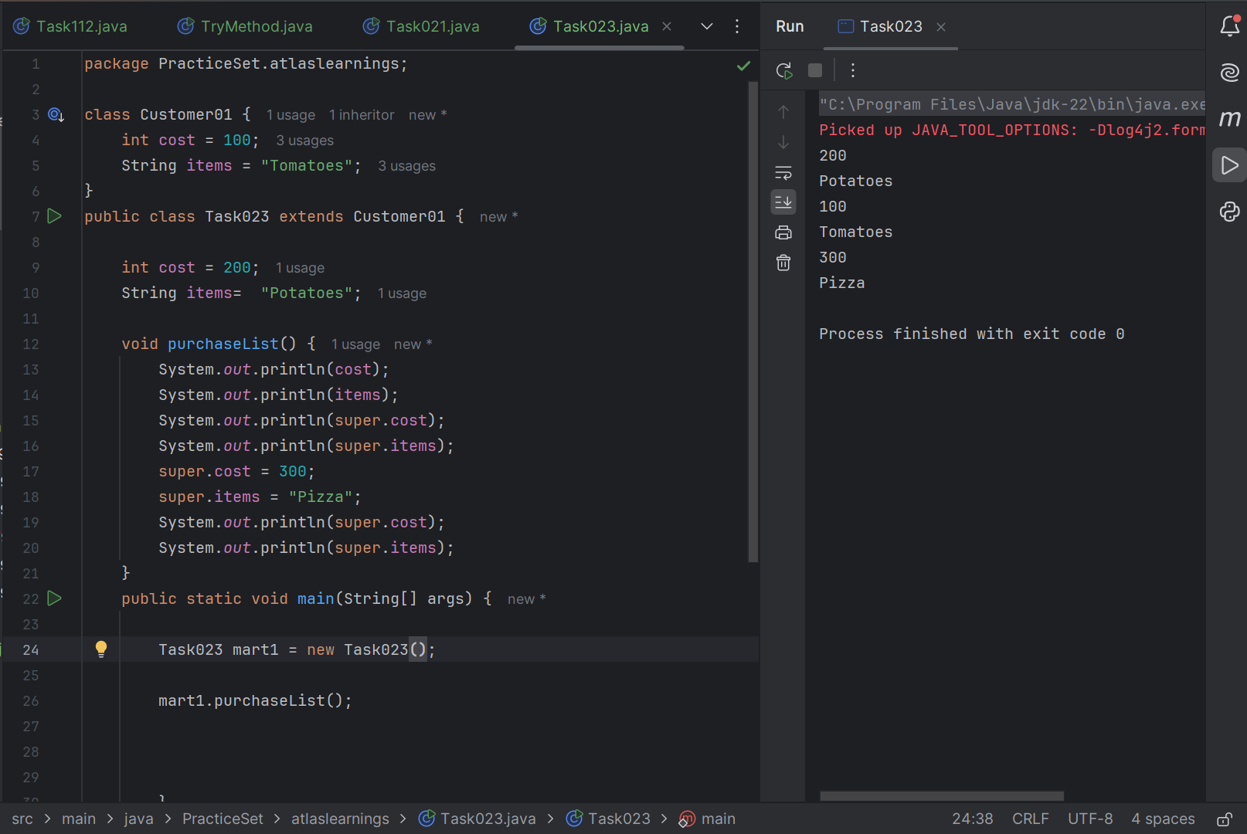

Task 23 A

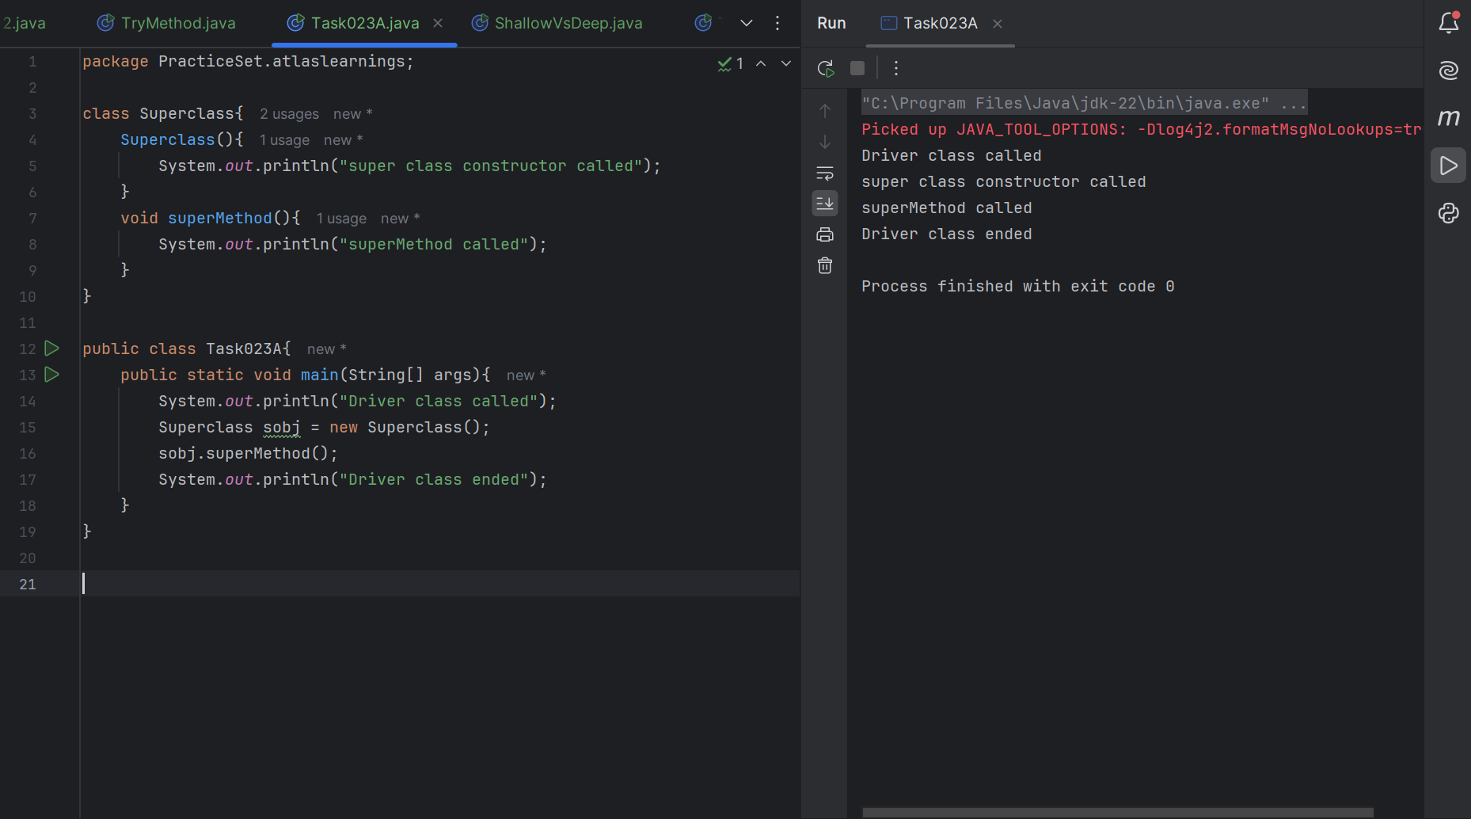

Task 24

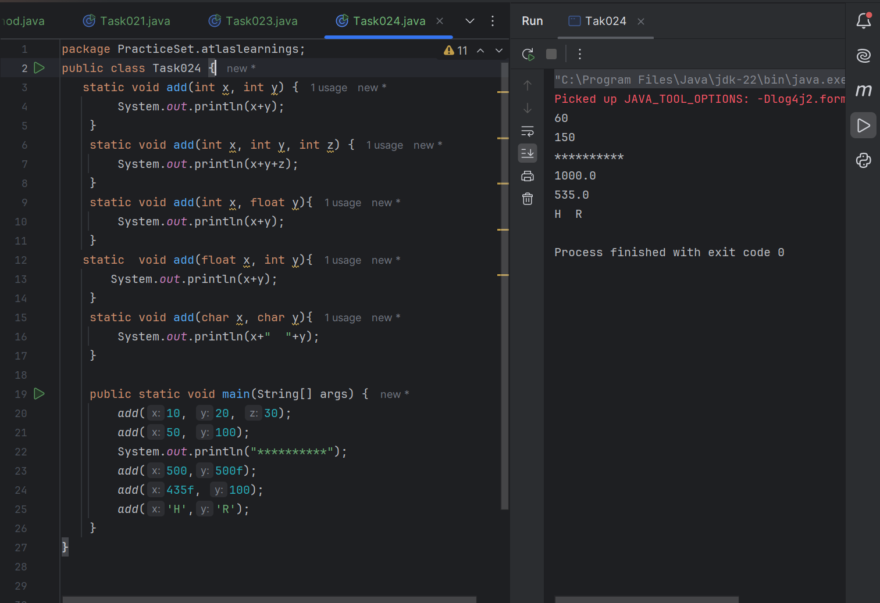

Task 25

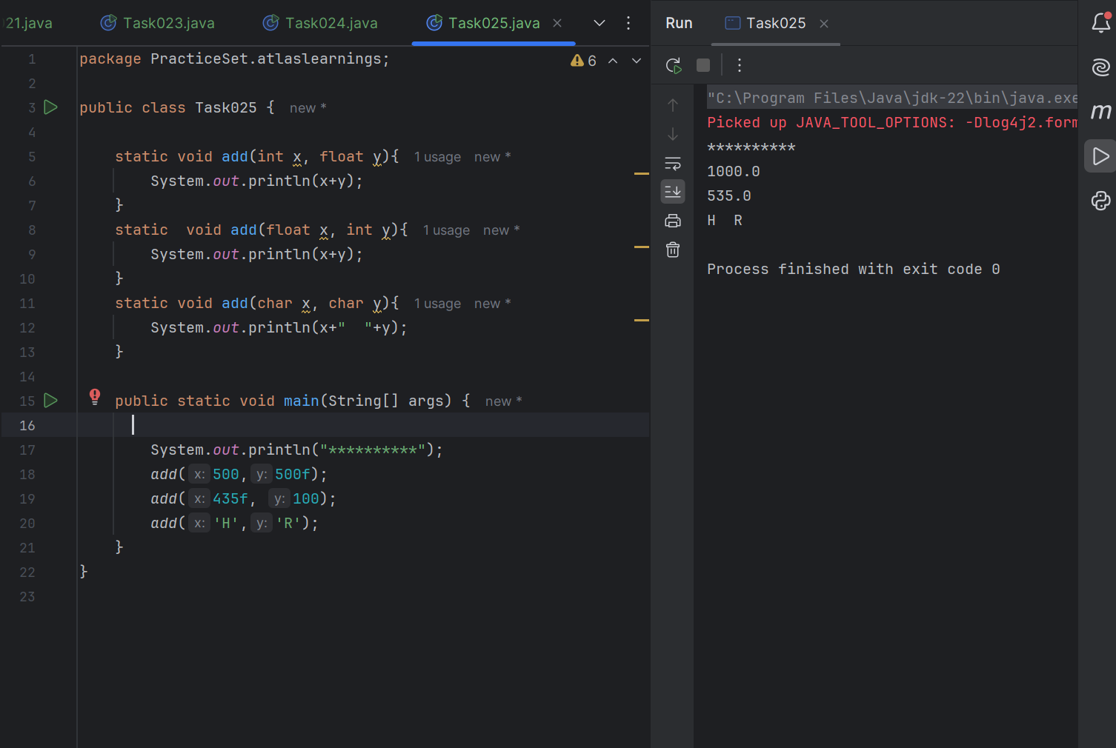

Task 26

Sequence of Parameters used



Task 27

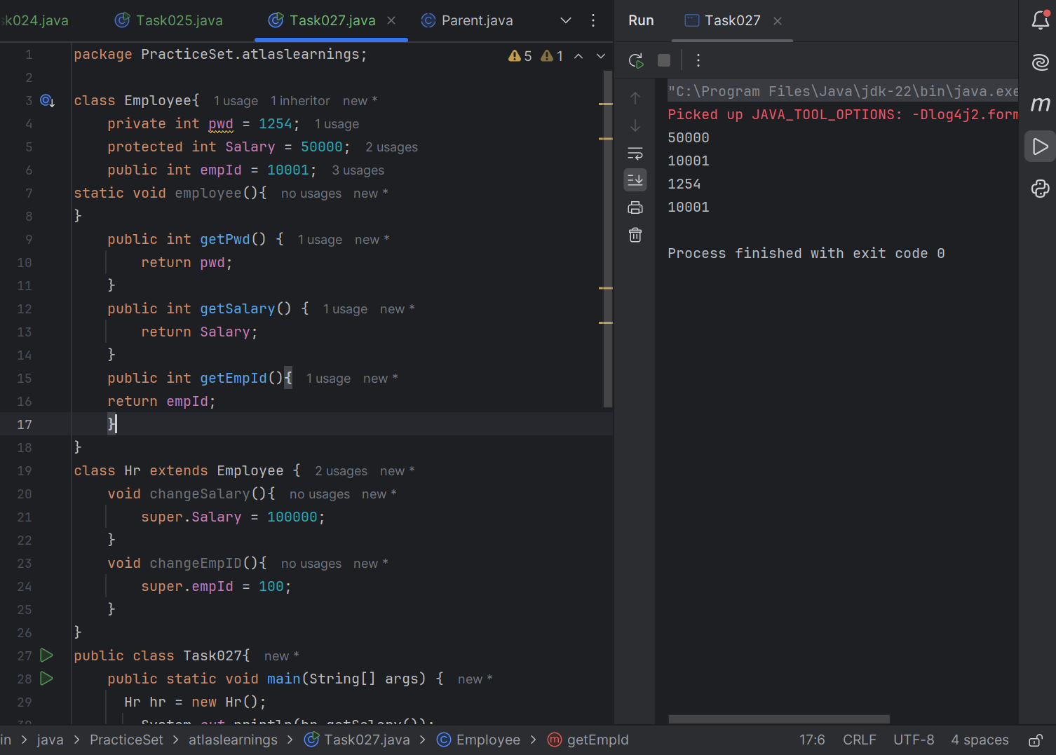

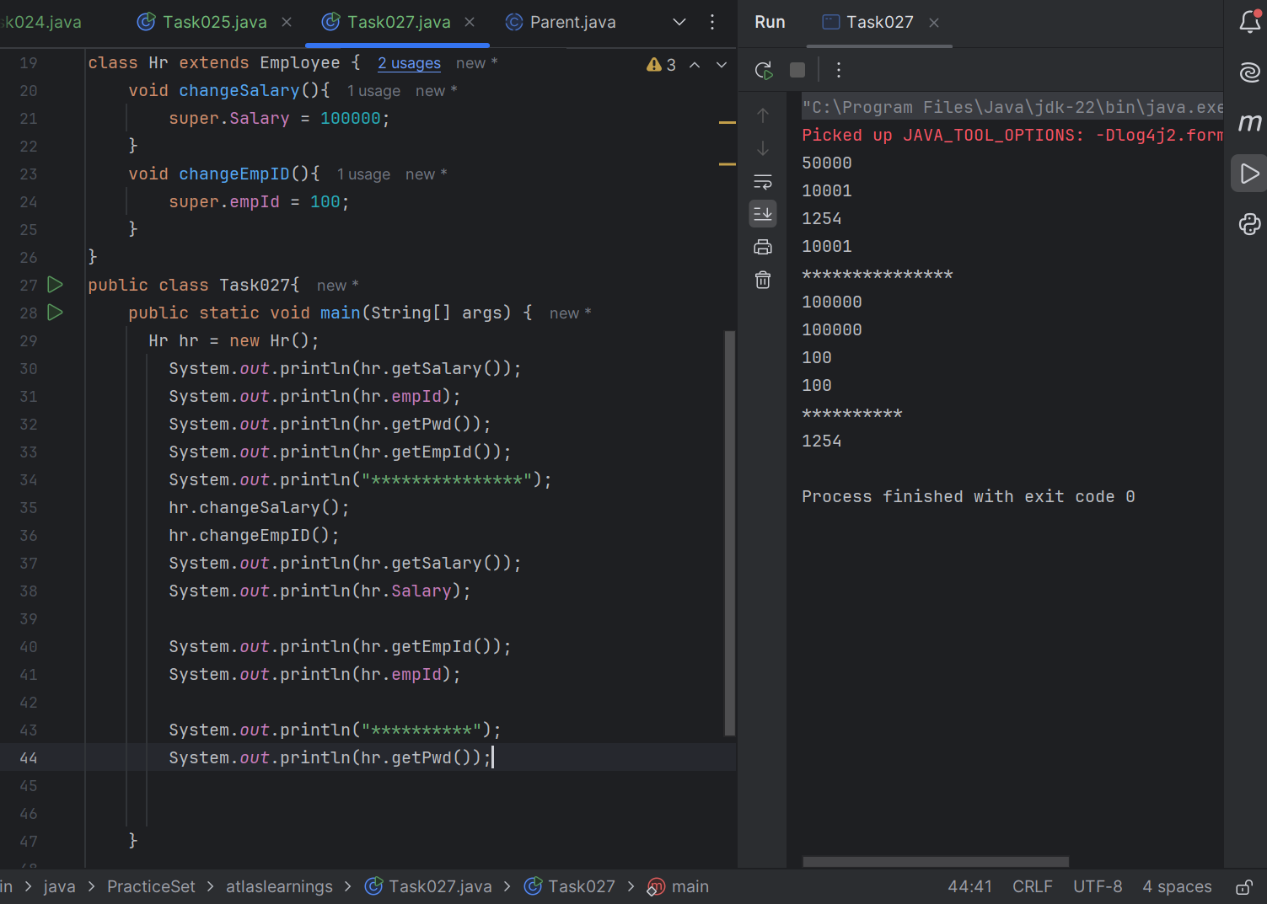

Task 28

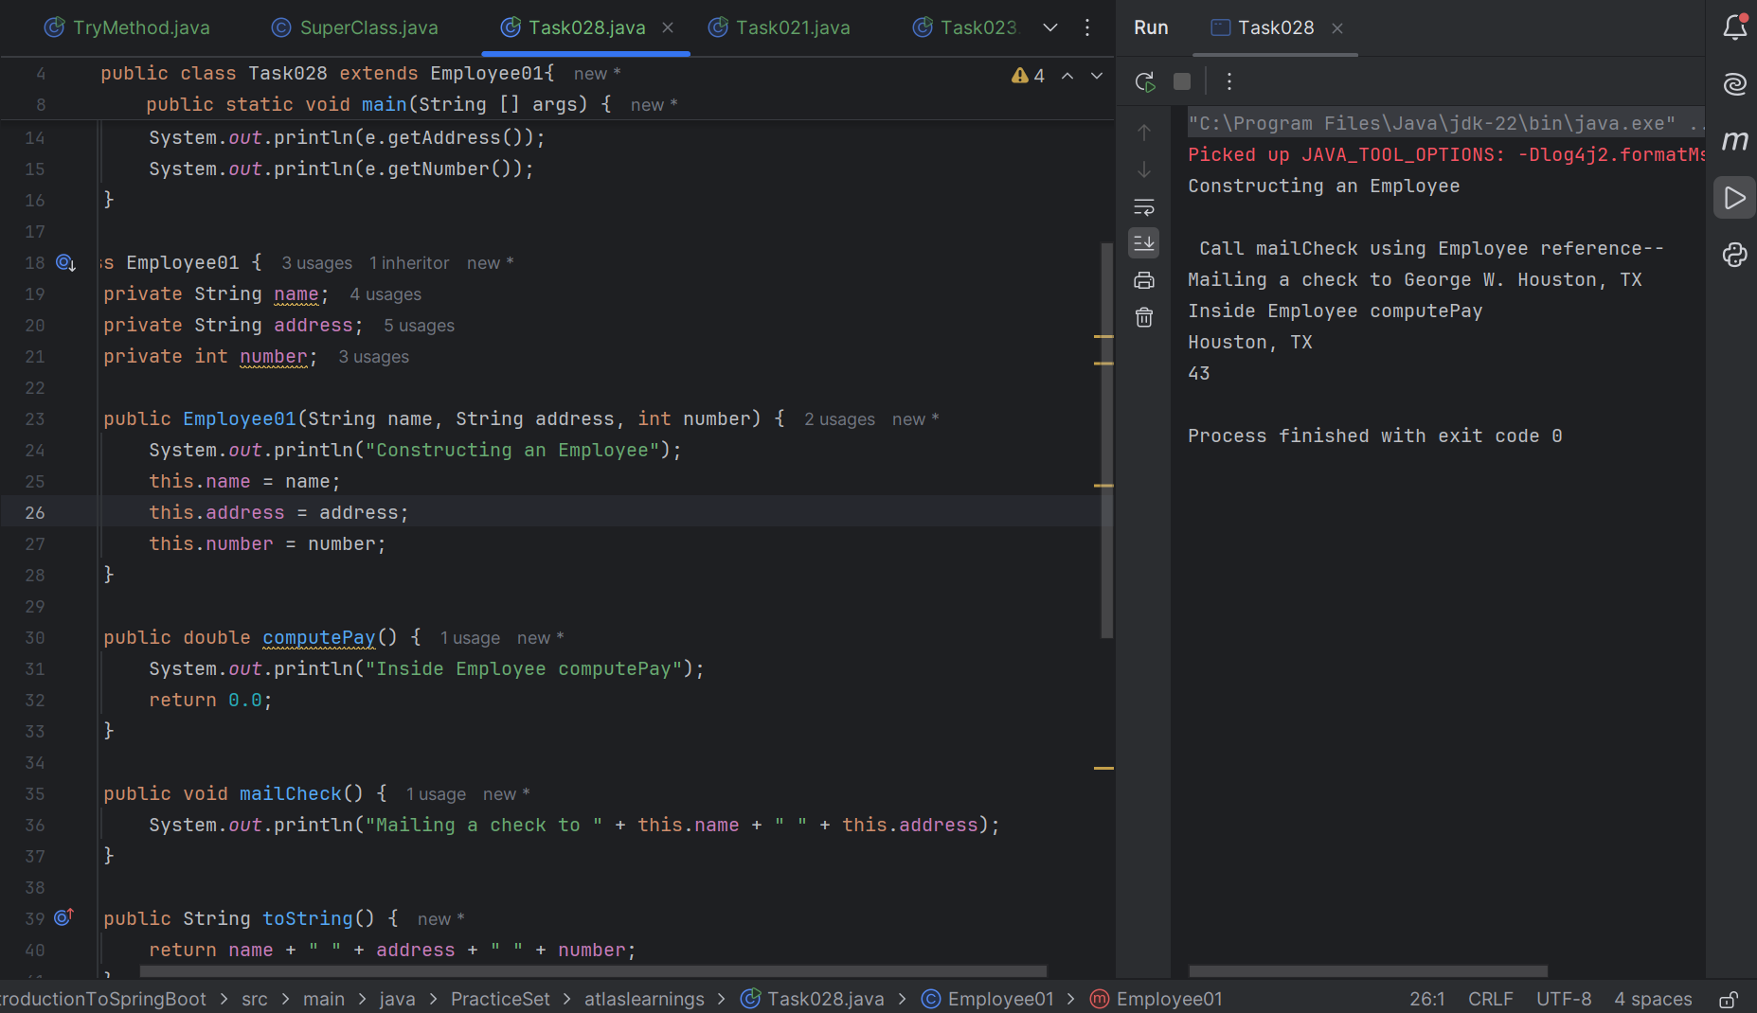

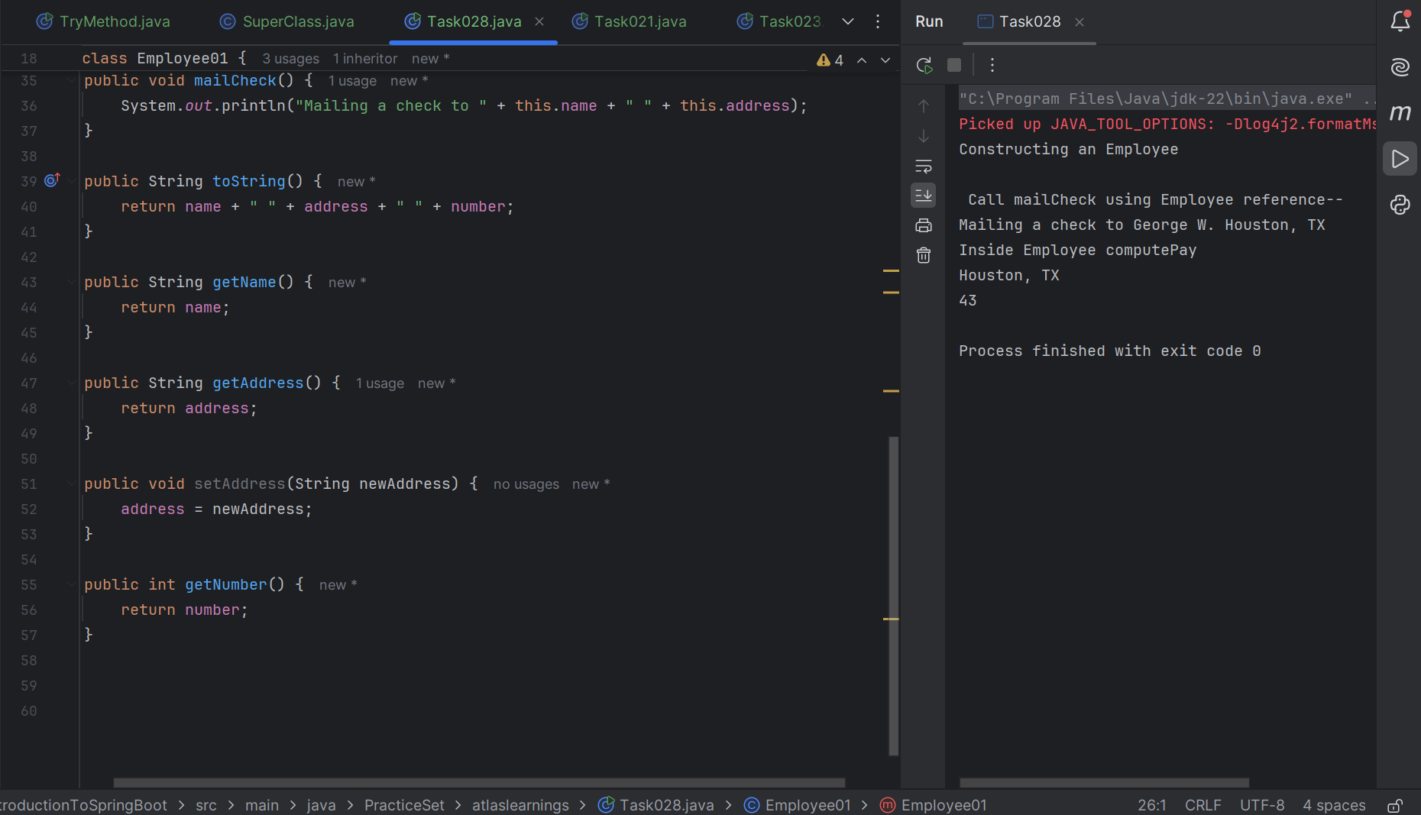

Task 29

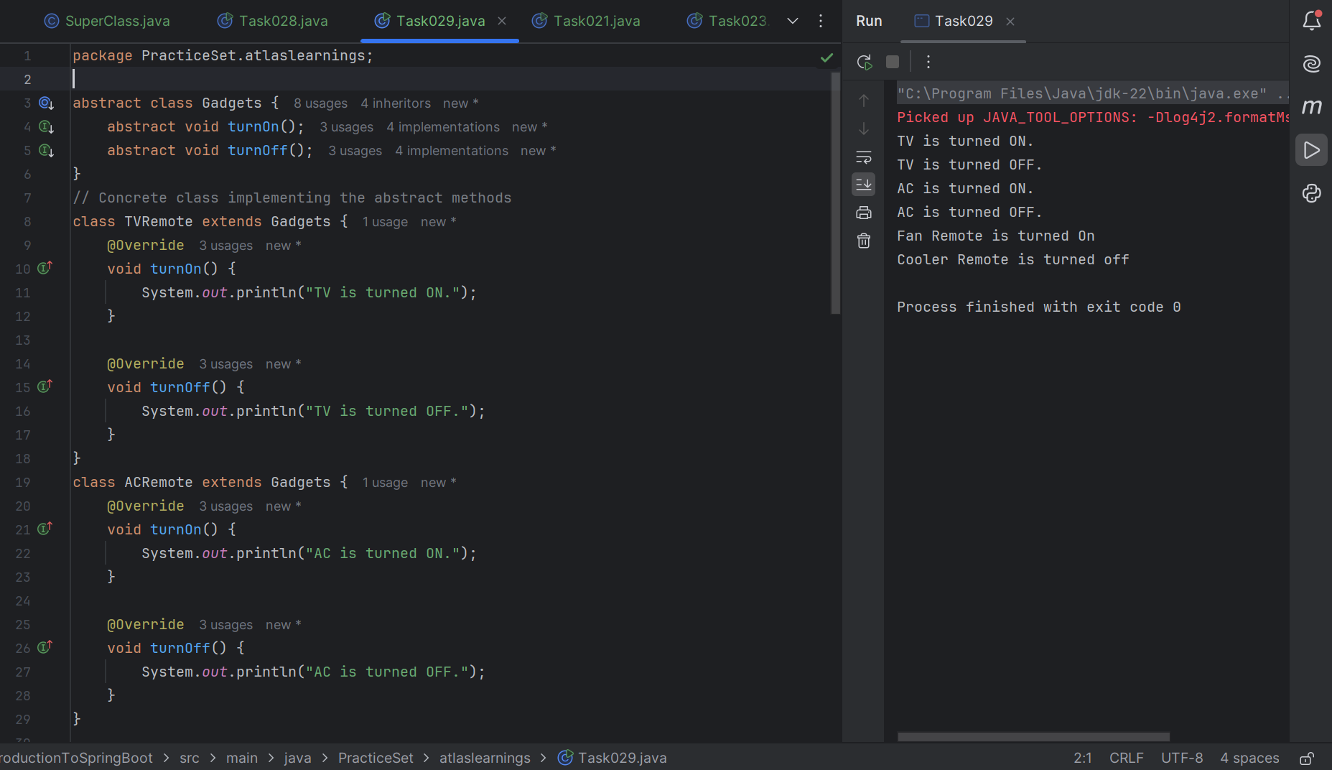

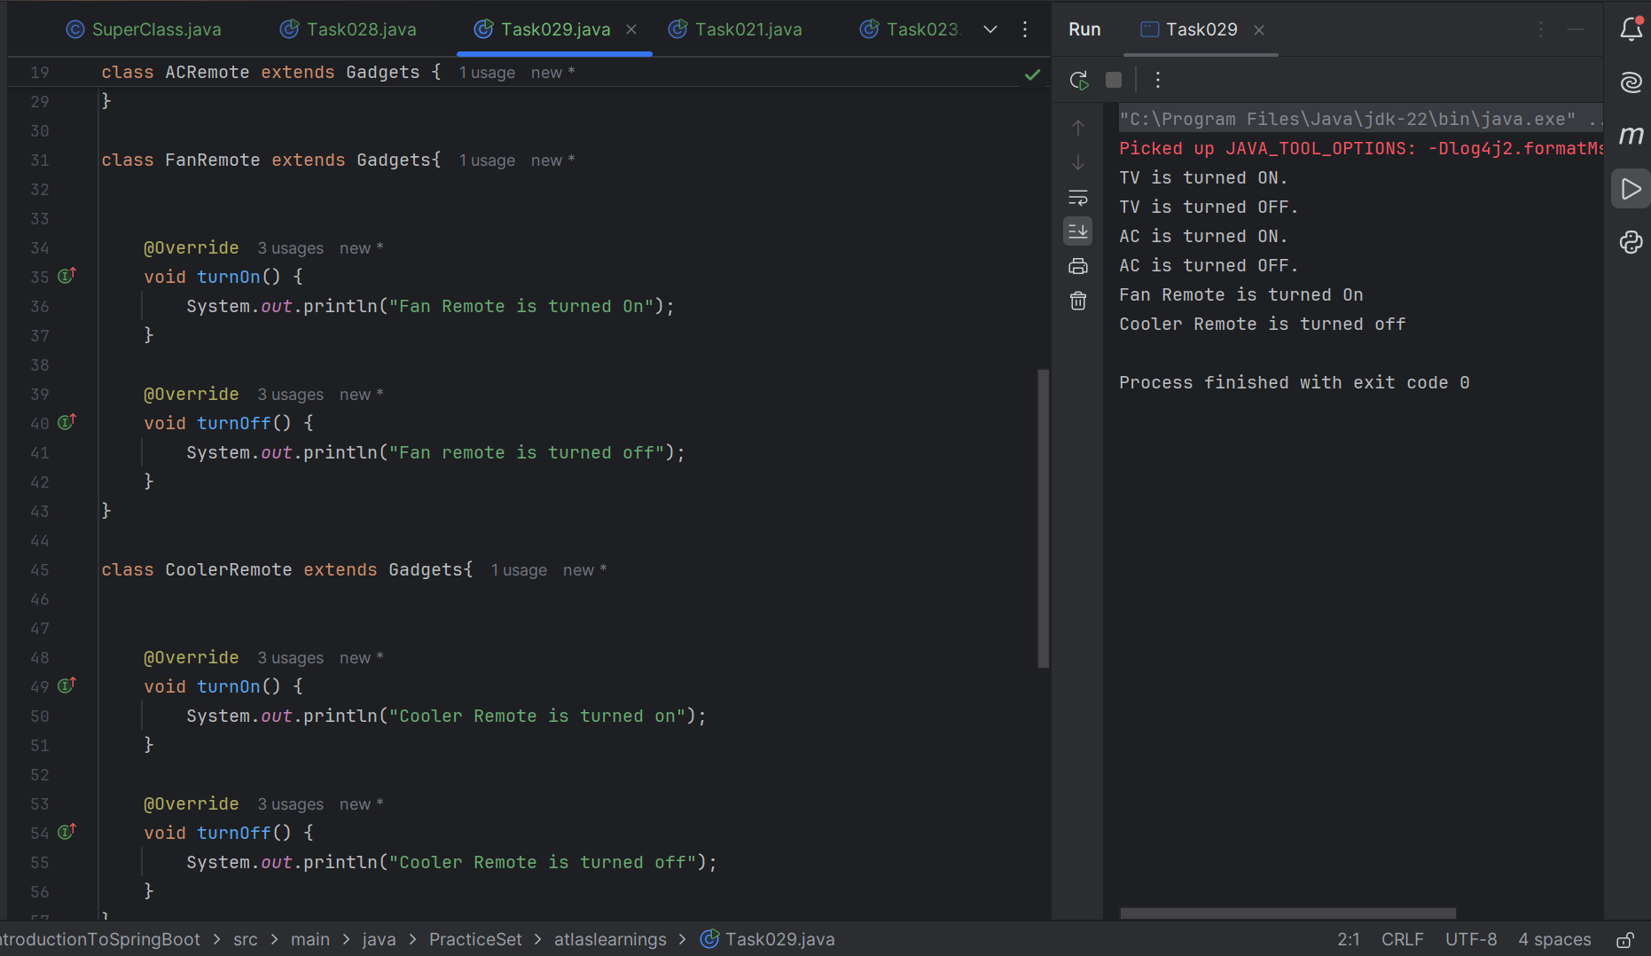

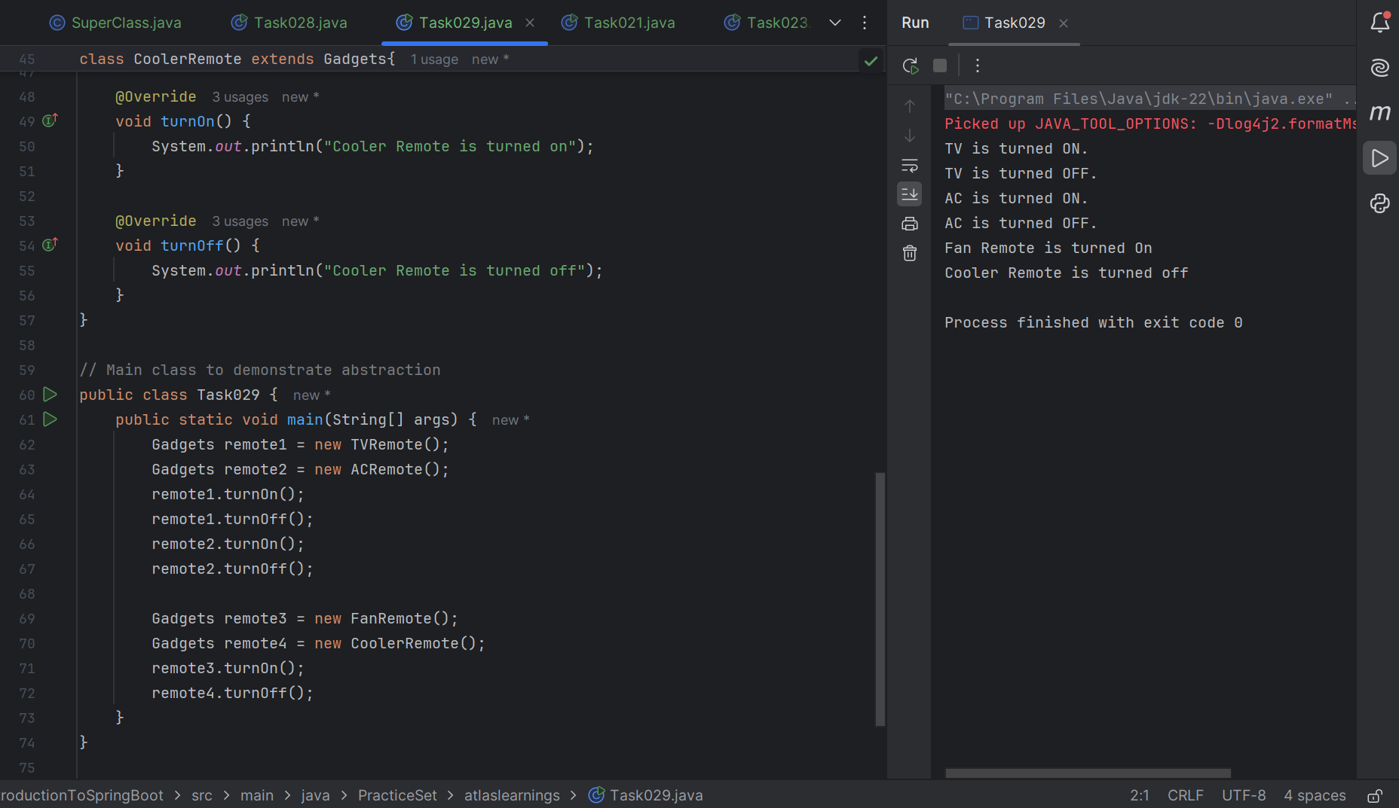

Task 30

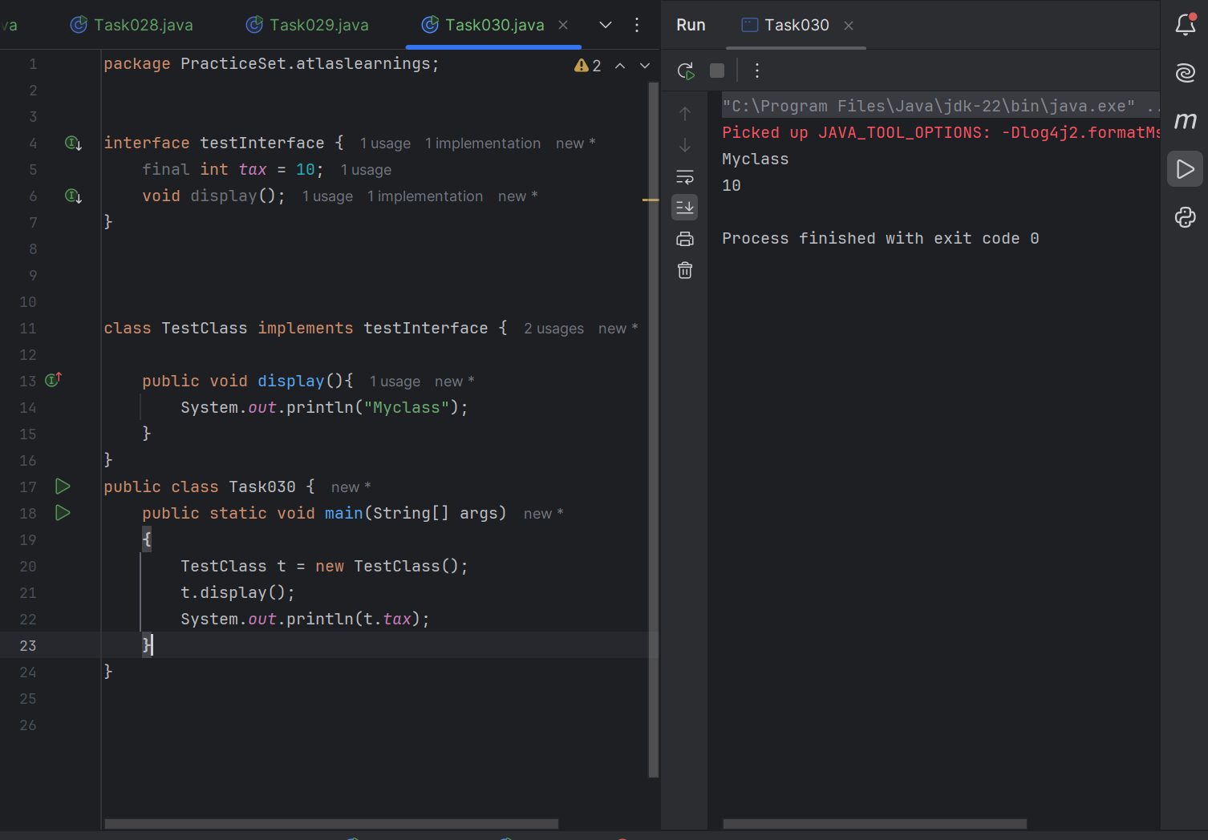

Task 31

Difference between constant and final

In Java, final is a keyword used to make a variable unchangeable after it is assigned. It can be used with variables, methods, and classes. A constant, on the other hand, is a special type of final variable that is also static and usually public, so it can be accessed globally. Constants are used to define fixed values like PI or MAX_VALUE, and are written in uppercase. So, all constants are final, but not all final variables are constants.